**2022 May Day MCM**

Problem C. Fire alarm system problem

Since the 1990s, the industrialization of fire detection and alarm in China has developed rapidly. There are more than 100 enterprises engaged in the production of fire detection and alarm products, with an annual output value of several billion yuan. It has become a part of the high-tech industry in China, and foreign products also enter our market in large quantities. There are about 2 million newly-installed fire detectors in China every year.

The function of the fire detector is to capture a specific fire signal, which is converted into electrical signals and transmitted to the fire alarm controller according to the alarm algorithm. When the detected signal value or variation characteristics exceed the threshold, it is judged as an occurred fire. Therefore, the sensitivity of the detector determines the sensitivity of the response to the fire characteristics, but the higher sensitivity will lead to a decrease of the alarm reliability, and the higher reliability needs to sacrifice the sensitivity of the detector. Therefore, the sensitivity and reliability of the detector become the key parameters to be balanced (For other relevant background information on fire alarm systems, see attachment 4: Background information on fire alarm systems).

Figure 1 shows the number and trend of fires in each month of 2021 in China. Assuming that the trend of the number of fires in one year in a city in China is similar to the number and trend of fires in each month of 2021 in China, the city received 257,179 fire alarm information (including false alarms caused by misoperation) within 18 days (June 1 to June 18). Attachment 1 is the fire alarm data of the city from June 1 to June 18. The city has 18 fire brigades, and the jurisdiction area is shown in table 1; in addition to misoperation, there are some fault problems in the fire alarm system in the city, as shown in attachment 2. It is assumed that the normal working fire detector will alarm when it detects a fire. Ignoring the influence of time, when multiple fire detectors in one building have the same machine number and loop number, and these detectors send out fire alarm signals, it is considered to be the same fire accident.

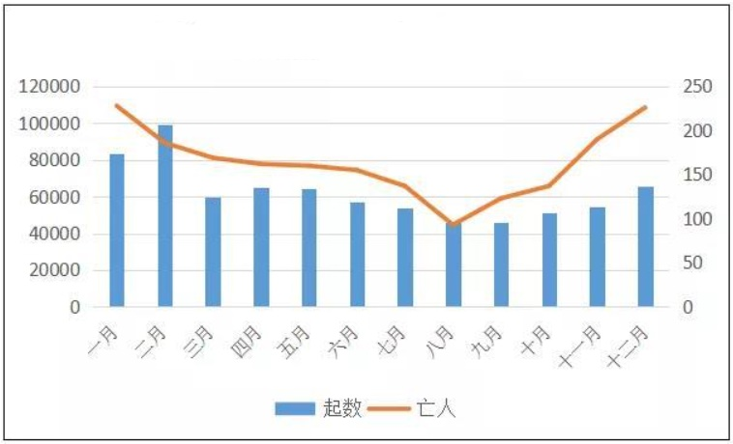

Figure 1 Number of fires ( left ) and deaths ( right ) in each month of 2021

Table 1 Jurisdiction area of each fire brigade

|  |  |
| --- | --- |
| **Name of the** **fire brigade** | **Jurisdiction area (square kilometers)** |
| Fire brigade A | 1712 |
| Fire brigade B | 692 |
| Fire brigade C | 1100 |
| Fire brigade D | 1631 |
| Fire brigade E | 412 |
| Fire brigade F | 1524 |
| Fire brigade G | 122 |
| Fire brigade H | 532 |
| Fire brigade I | 96 |
| Fire brigade J | 58 |
| Fire brigade K | 1831 |
| Fire brigade L | 1561 |
| Fire brigade M | 1997 |
| Fire brigade N | 246 |
| Fire brigade O | 483 |
| Fire brigade P | 24 |
| Fire brigade Q | 2151 |
| Fire brigade R | 13 |

On the assumption that the detector is properly installed and meets the standards, discuss the following questions:

**Question 1:** Please determine the real number of fires in the city from June 1 to June 18 according to the previous descriptions and attachment 1, and read some relevant references. Combined with attachment 2 and Figure. 1 (Parts of the component in attachment 2 need not be analyzed, and the components in attachment 2 should be screened according to the name of the components in attachment 1). By establishing a model, analyze the various types of components in attachment 1, and use the reliability and failure rate to evaluate the various types of components, so as to help the government select a more reliable type of fire detector.

**Question 2:** By reading the references and combining them with the data conclusions obtained in question 1, select the appropriate parameters to establish the intelligent judgment model of regional alarm component types. When the alarm information is issued by a certain type of component within the jurisdiction of a certain team, it can better judge whether it is a false alarm and improve the alarming accuracy. Evaluate the authenticity of the alarm signals issued by different components of each team in attachment 3 to determine the probability that the alarm signals in attachment 3 are real fires.

**Question 3:** According to the fire data of each jurisdiction obtained in question 1 and the results of question 2, combined with table 1, analyze the comprehensive management level of each fire brigade in the city, and quantify the technical indicators of the three jurisdictions with the lowest comprehensive management level (such as fire frequency, component failure rate, component reliability, etc.), and propose the improvement scheme.

**Question 4:** According to the relevant literature and the results of questions 1 to 3, please put forward suggestions for the management and maintenance of each component of the fire alarm system.